**PAT**

**1. About PAT**

Programming ability test, whose abbreviation is PAT, is a unified examination jointly sponsored and organized by National Higher Education Teaching and Research Center, iCourses Network, and the School of Computer Science and Technology of Zhejiang University. It aims to cultivate and demonstrate students' ability to analyze problems, solve problems and grade programming, scientifically evaluate computer programming talents, and provide reference standards for enterprises to select talents.

**1.1. Company Alliance**

PAT provides a standardized reference for corporate recruitment and selection of outstanding IT talent, and can reduce recruitment costs, which is welcomed by more and more corporate human resources departments and IT technology departments. Since August 2011, PAT has launched a “Company Alliance”, which promises to provide excellent candidates with information for companies within the Alliance. The company also promises not to disclose candidates' information, and to give priority to students with excellent PAT scores, and to waive the written test procedures related to the design process ability during recruitment. Alliance companies may propose special green channel conditions to PAT, and their specific conditions will be listed on the PAT registration website for candidates to view.

**1.2. About Web Page**

The website has eight modules, namely the home page, enter registration, news, PAT introduction, company alliance, test center alliance, badge mall, personal information. The website as a whole adopts the popular minimalist flat style, which is in line with the website theme. It screens out redundant information and maximizes useful information.

**1.2.1. The Home Page**

When you enter the homepage, you will see the latest exam registration information, as well as the buttons related to the exam-related courses, exam information, check-ups, and real-question exercises. Users can do course study and test exercises here. The purpose of the entire site is very clear. At the same time, the home page serves to navigate the entire site. [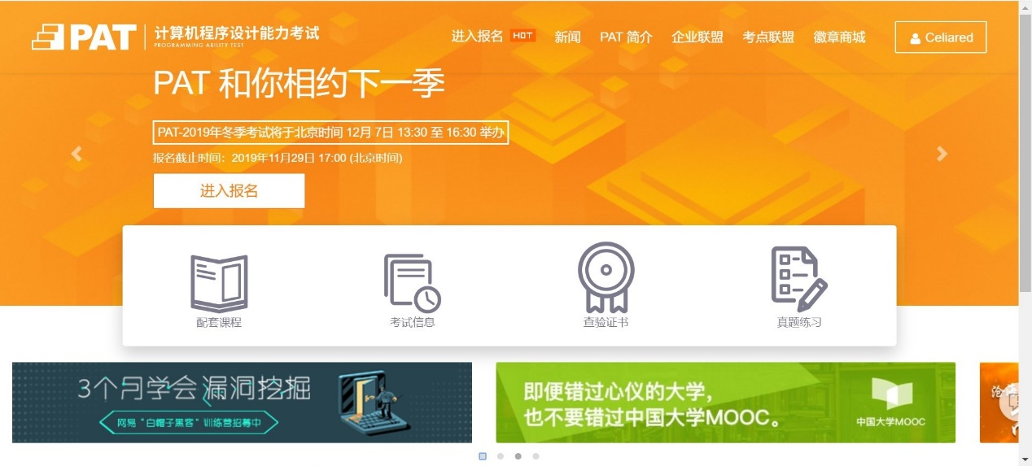](https://github.com/ECNU-DEIT-ACADEMIC-2019/PAT/blob/master/1.2.1.jpg?raw=true)

**1.2.1.1. Supporting Course**

You can take exam-related courses here, and the course resources are provided by iCourse website. [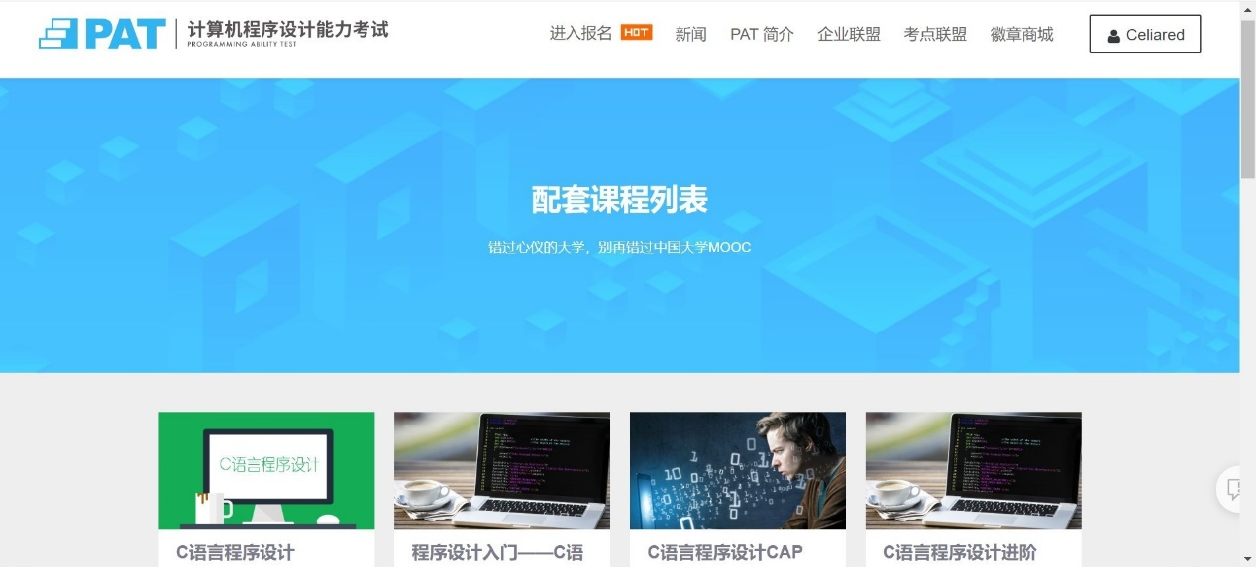](https://github.com/ECNU-DEIT-ACADEMIC-2019/PAT/blob/master/1.2.1.1.jpg?raw=true)

**1.2.1.2. Test Information**

You can get test information here. [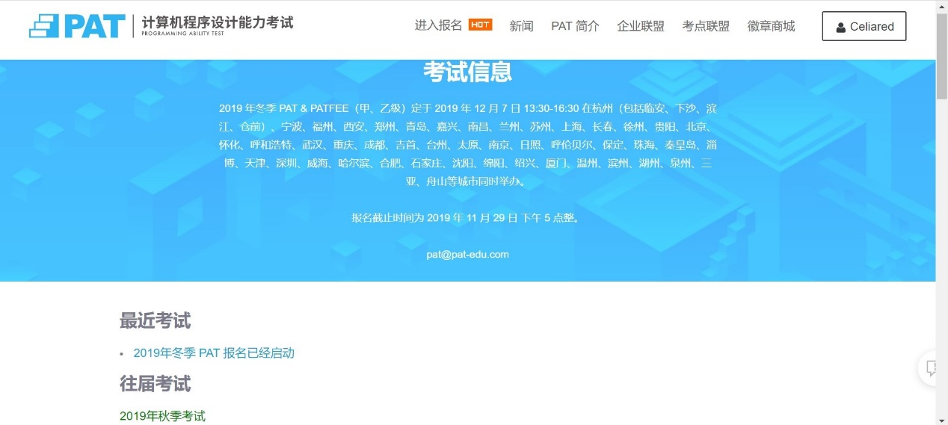](https://github.com/ECNU-DEIT-ACADEMIC-2019/PAT/blob/master/1.2.1.2.jpg?raw=true)

#### 1.2.1.3. Certificate

You can check your certificate here. [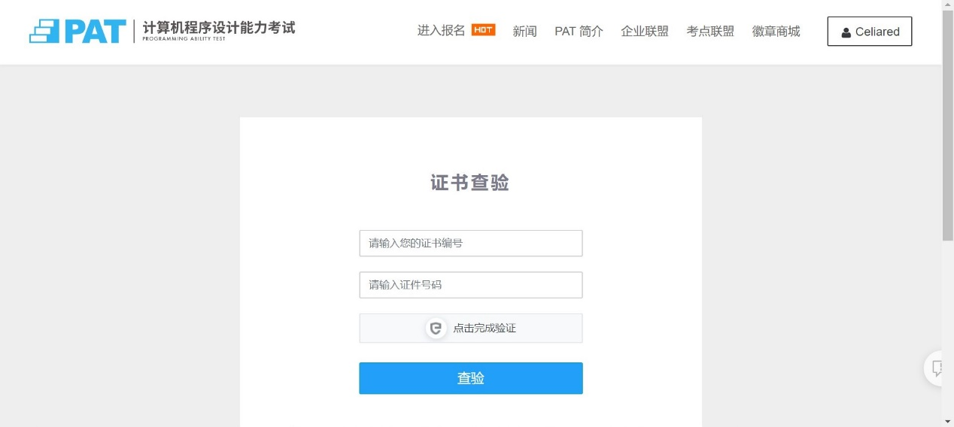](https://github.com/ECNU-DEIT-ACADEMIC-2019/PAT/blob/master/1.2.1.3.jpg?raw=true)

#### 1.2.1.4. Test exercises

You can practice different levels of test exercises here. [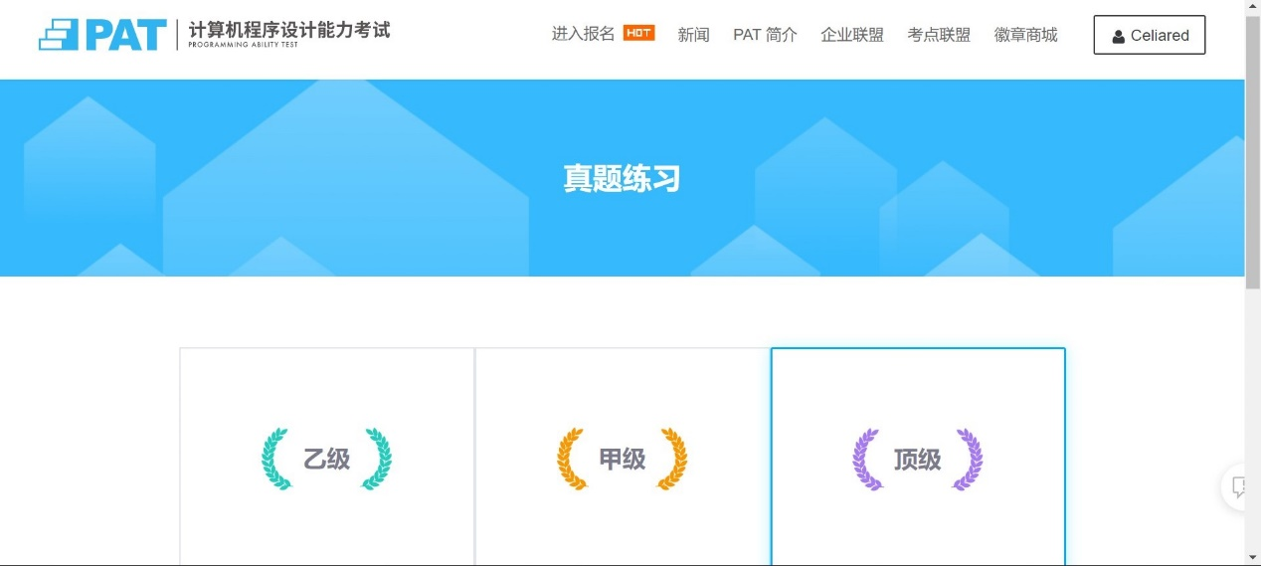](https://github.com/ECNU-DEIT-ACADEMIC-2019/PAT/blob/master/1.2.1.4.jpg?raw=true)

#### 1.2.2. Registration

The registration interface displays relevant exam information and registration steps. [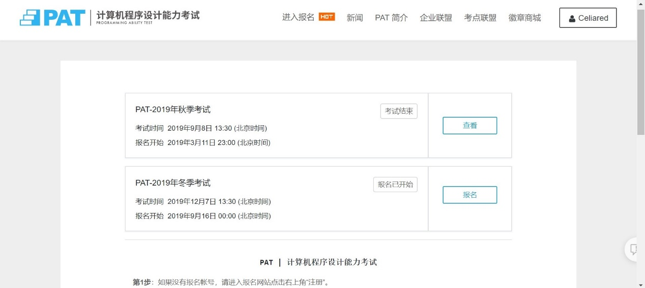](https://github.com/ECNU-DEIT-ACADEMIC-2019/PAT/blob/master/1.2.2.jpg?raw=true)

#### 1.2.3. News:

The news interface is used to present news related to the PAT exam, such as new colleges and universities, companies and other news. [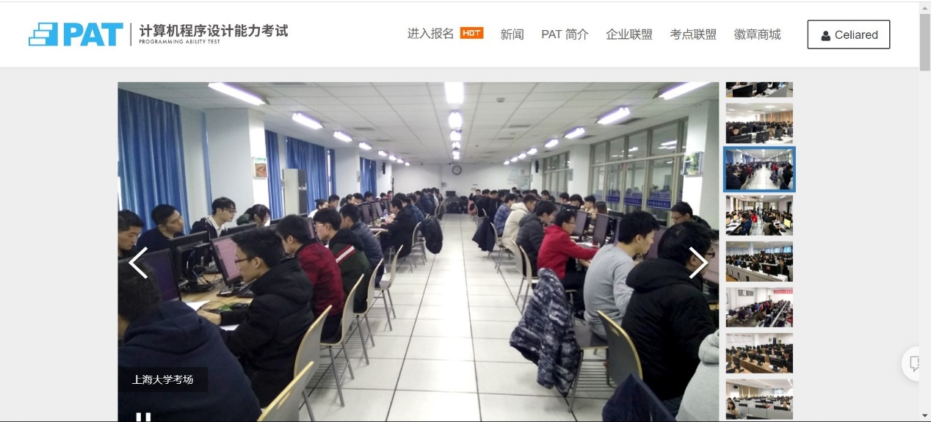](https://github.com/ECNU-DEIT-ACADEMIC-2019/PAT/blob/master/1.2.3.jpg?raw=true)

#### 1.2.4. PAT Introduction

PAT introduction section includes basic information on the PAT exam, including information for candidates, company alliances, exam syllabus, grades and certificates, and college alliances. [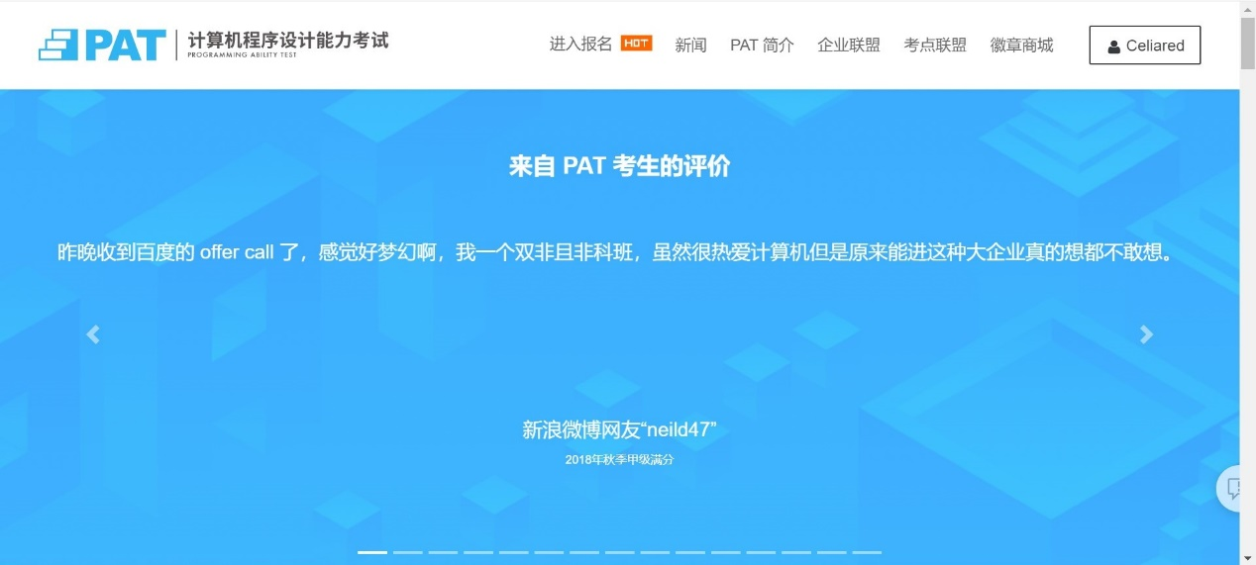](https://github.com/ECNU-DEIT-ACADEMIC-2019/PAT/blob/master/1.2.4.jpg?raw=true)

#### 1.2.5. Company Alliances

PAT provides a standardized reference for corporate recruitment and selection of outstanding IT talents, and can reduce recruitment costs, which is welcomed by more and more corporate human resources departments and IT technology departments. Company alliance interface provides information such as PAT alliance company information and the process of joining for companies. [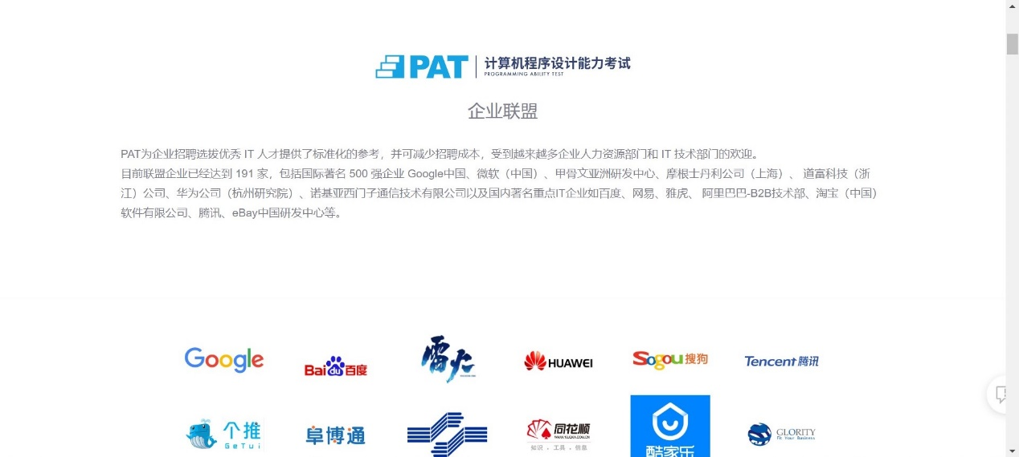](https://github.com/ECNU-DEIT-ACADEMIC-2019/PAT/blob/master/1.2.5.jpg?raw=true)

#### 1.2.6. Test Center Alliance

Test center alliance interface provides test places information across the country. [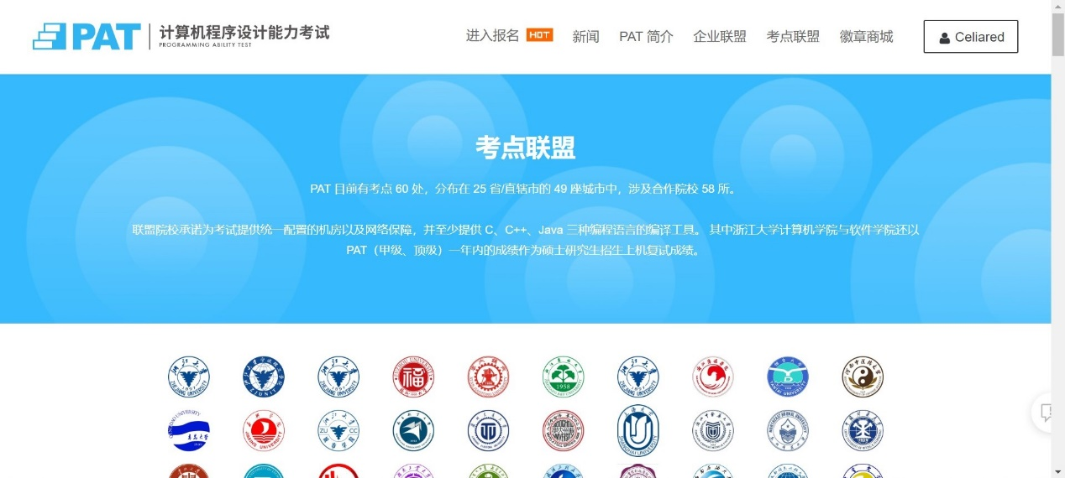](https://github.com/ECNU-DEIT-ACADEMIC-2019/PAT/blob/master/1.2.6.jpg?raw=true)

#### 1.2.7. Badge Mall

You can purchase badges in the badge store by taking PAT and obtaining a certificate. [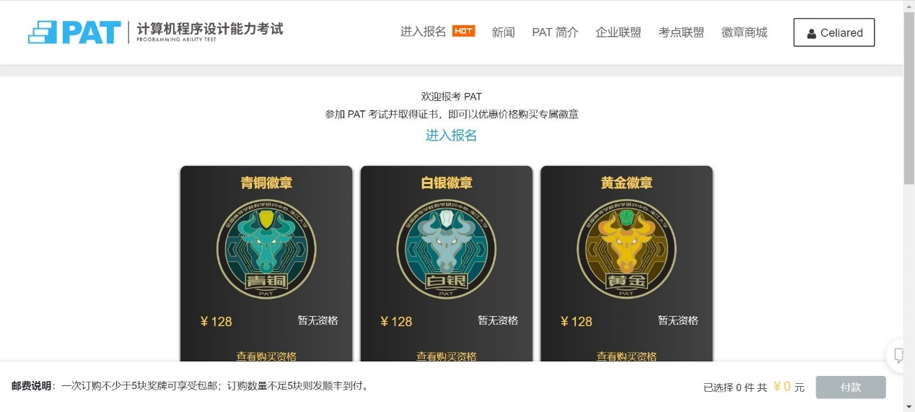](https://github.com/ECNU-DEIT-ACADEMIC-2019/PAT/blob/master/1.2.7.jpg?raw=true)

#### 1.2.8. Personal Information

About yourself. [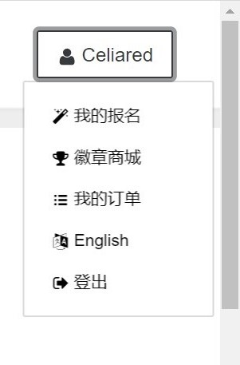](https://github.com/ECNU-DEIT-ACADEMIC-2019/PAT/blob/master/1.2.8.jpg?raw=true)

## 3.interaction

We will introduce from two aspects of instructional interaction and interface interaction.The instructional interaction of E-learning platform is defined as the method and process of information exchange among teaching elements supported by the network teaching environment, which mainly includes teacher-student interaction, student-student interaction and teacher-student and learning materials.

### 3.1.Instructional interaction

The instructional interaction of the PAT website we chose is mainly reflected in the discussion boards, courseware, quizzes and other sections of the supporting courses.The supporting courses of PAT platform are directly linked to the MOOC network of Chinese universities. The discussion section is divided into five sub-sections, namely, teacher answer section, classroom communication section, comprehensive discussion section, test assignment discussion section and programming software communication section. [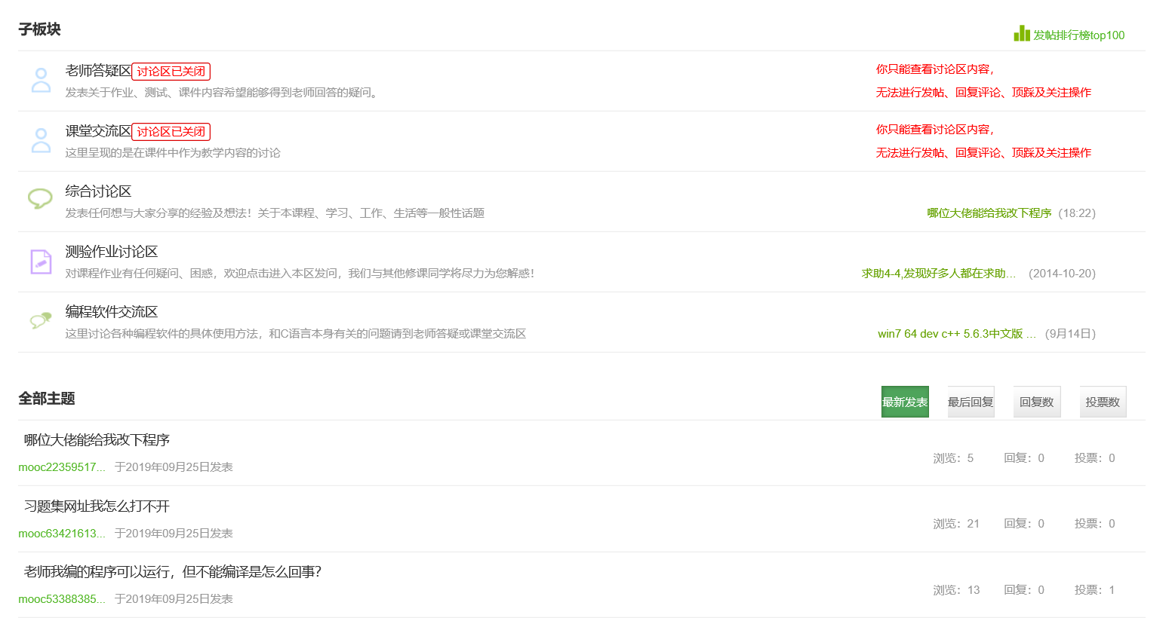](https://github.com/ECNU-DEIT-ACADEMIC-2019/PAT/blob/master/3.1.PNG?raw=true)

#### 3.1.1.Teacher-student interaction

In the process of platform learning, teachers assume the roles of organizer, mentor and helper.。Immediate and effective interaction between teachers and students can correctly guide and supervise students to complete the learning process successfully. In PAT platform, the teacher-student interaction is mainly reflected in the teacher’answer area and classroom communication area.Students can post their doubts to the teacher's answer area and classroom communication area, and the teacher can give feedback and suggestions on students' questions at any time, so as to promote further learning. [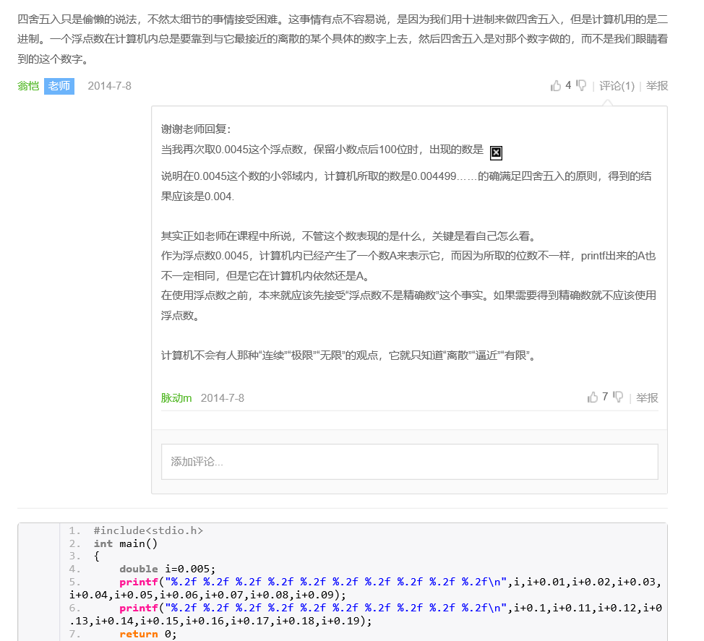](https://github.com/ECNU-DEIT-ACADEMIC-2019/PAT/blob/master/3.1.1.PNG?raw=true)[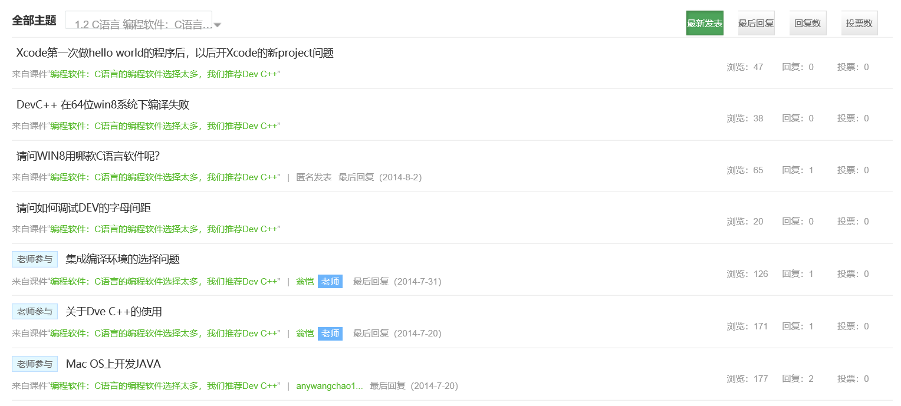](https://github.com/ECNU-DEIT-ACADEMIC-2019/PAT/blob/master/3.1.2.PNG?raw=true)

#### 3.1.2.Student-student interaction

In the process of using the platform for learning, the interaction and collaboration between students can help eliminate the sense of loneliness and create a collective learning atmosphere. PAT platform fully realizes the interaction between students and students, which is mainly reflected in the classroom communication area, comprehensive discussion area, test assignment discussion area and programming software communication area.Classroom communication area is mainly for learning content to ask, discuss,;Comprehensive discussion forum is not limited to courses, such as course certificate, language environment, etc.The discussion section of test assignments discusses and exchanges specific questions on specific tests.Programming software communication area is mainly for programming software communication.Each district has its own discussion topic to meet learners' personalized learning needs and enrich their learning experience, so as to master the knowledge more comprehensively and deeply. [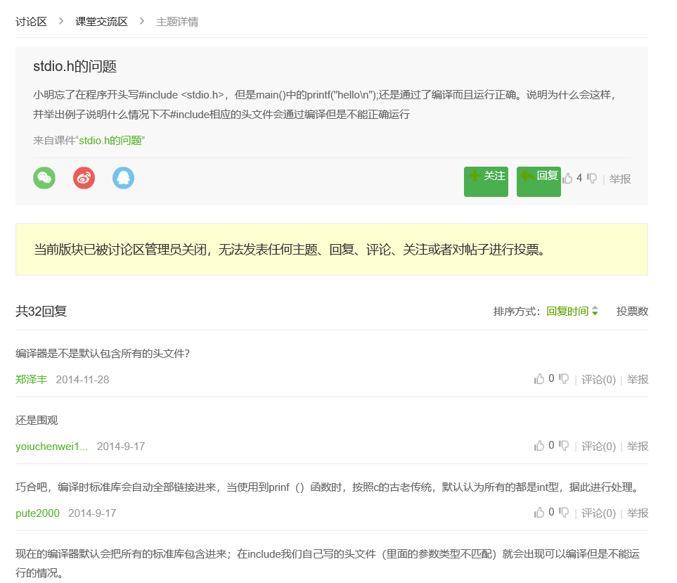](https://github.com/ECNU-DEIT-ACADEMIC-2019/PAT/blob/master/3.2.1.PNG?raw=true)[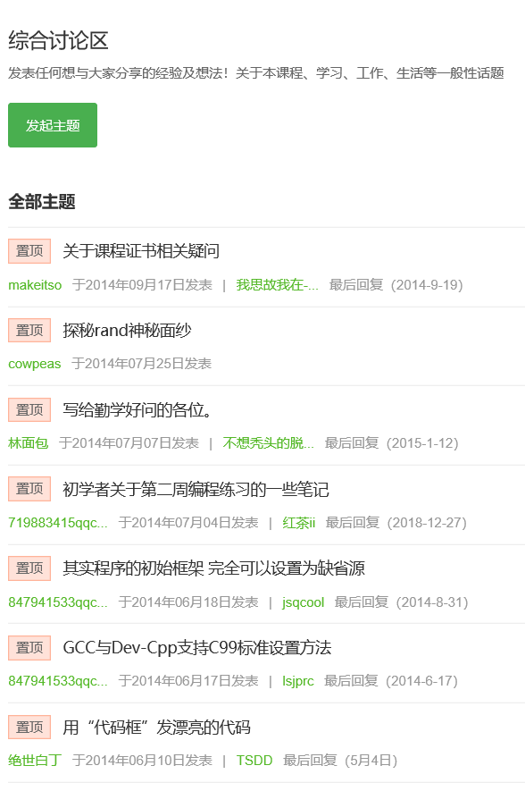](https://github.com/ECNU-DEIT-ACADEMIC-2019/PAT/blob/master/3.2.2.PNG?raw=true)[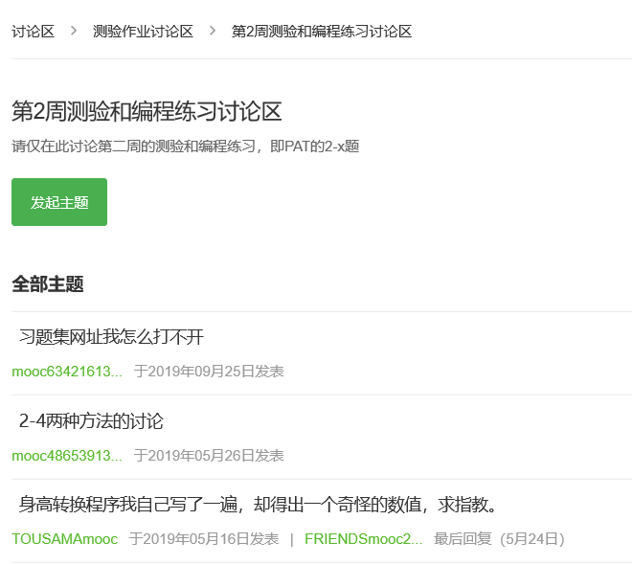](https://github.com/ECNU-DEIT-ACADEMIC-2019/PAT/blob/master/3.2.3.PNG?raw=true)[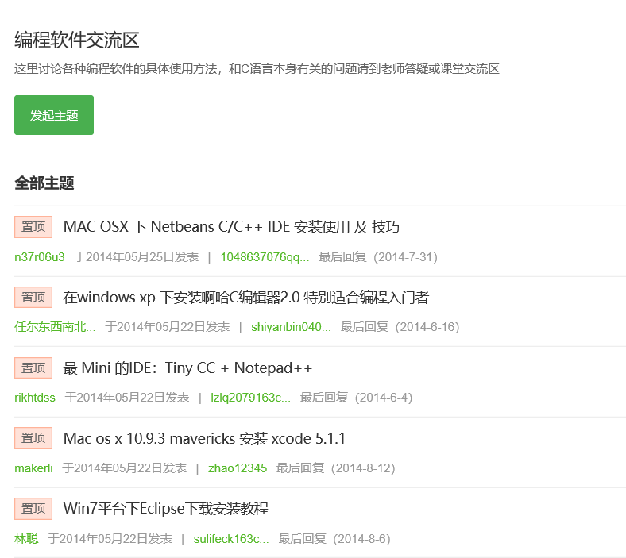](https://github.com/ECNU-DEIT-ACADEMIC-2019/PAT/blob/master/3.2.4.PNG?raw=true)

#### 3.1.3.Resource interaction

Resource interaction means that teachers release learning contents and tasks through the platform, such as courseware, tests, reference materials, etc. Students complete the tasks through learning resources.It is reflected in the courseware, tests and assignments, textbooks and online reference materials of PAT platform.The resources provided by the supporting courses include video, lecture notes, literature, etc., which are available for students to download and save and facilitate students to expand their knowledge. [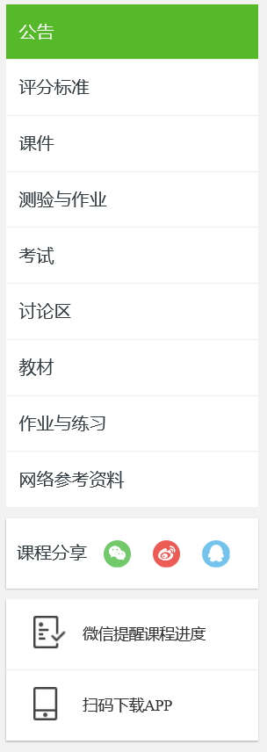](https://github.com/ECNU-DEIT-ACADEMIC-2019/PAT/blob/master/3.3.1.PNG?raw=true)[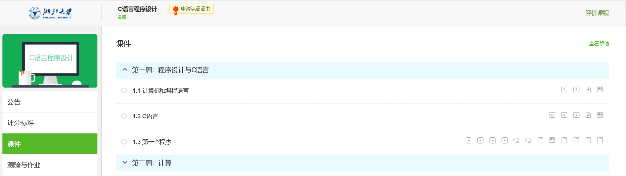](https://github.com/ECNU-DEIT-ACADEMIC-2019/PAT/blob/master/3.3.2.PNG?raw=true)

In the PAT platform exercise module, there are C language program, data structure and other topic sets, which can help students systematically train their programming knowledge and skills.After entering the exercise module and submitting it, time consumption, scores and correct answers will be displayed.If you enter the submission list on the left, you can see the title submitted by the user, and click the serial number of the title to directly open the specific title.The ranking list on the left shows the ranking of all users.The exercises can help students to independently choose the question bank of the exercises, and have immediate feedback, as well as their own ranking in all users, which is conducive to positioning their learning level and enhancing their learning motivation. [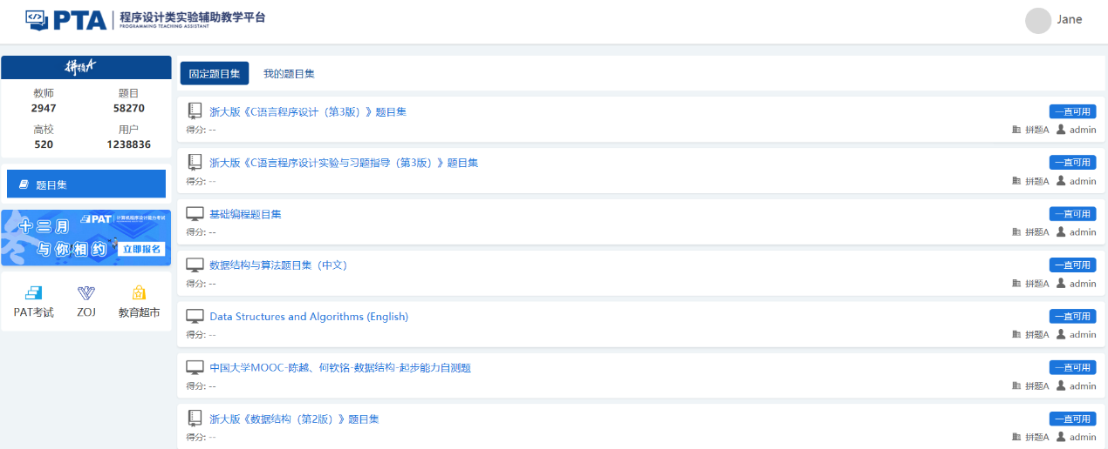](https://github.com/ECNU-DEIT-ACADEMIC-2019/PAT/blob/master/3.3.3.PNG?raw=true)[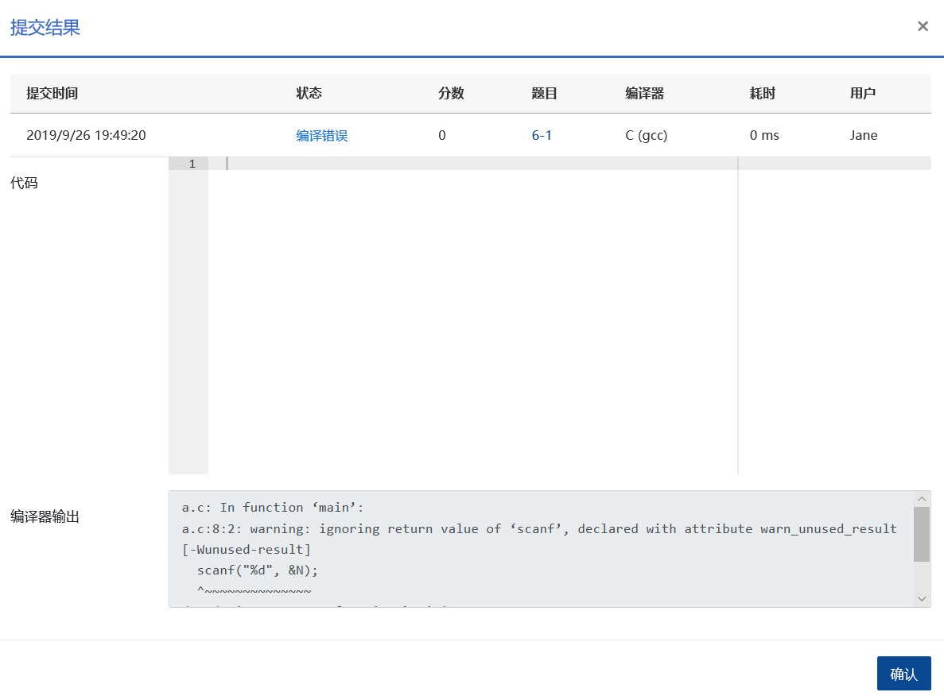](https://github.com/ECNU-DEIT-ACADEMIC-2019/PAT/blob/master/3.3.4.PNG?raw=true)[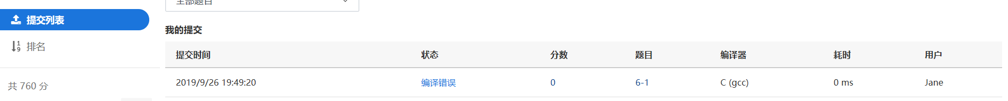](https://github.com/ECNU-DEIT-ACADEMIC-2019/PAT/blob/master/3.3.5.PNG?raw=true)[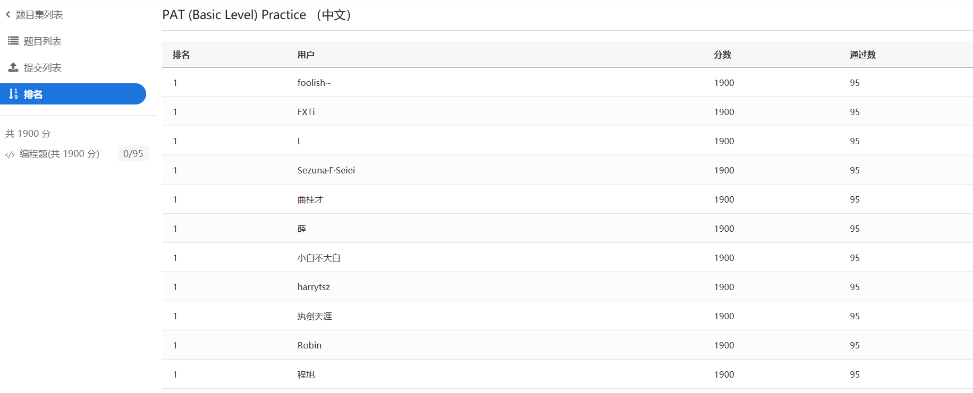](https://github.com/ECNU-DEIT-ACADEMIC-2019/PAT/blob/master/3.3.6.PNG?raw=true)

#### 3.1.4.Summary

In general, the teaching interaction of PAT platform is relatively complete, including teacher-student interaction, student-student interaction and resource interaction.However, it is almost all reflected in the discussion board and exercise module, where appropriate interaction modes can be set in other sections. For example, a small assistant can be set to answer questions online at any time to answer any questions encountered by users in the process of using the platform, so as to enhance the intelligence and sense of belonging of the platform.

### 3.2.Interface interaction

The interactivity of PAT website is better overall, pay attention to user experience, easy to operate, easy for users to grasp.For example, when the mouse moves to an operational position, the system will give immediate feedback and perform the user's operation.Most operation pages can be returned to the main page by clicking the PAT logo in the upper left corner. [](https://github.com/ECNU-DEIT-ACADEMIC-2019/PAT/blob/master/3.4.1.PNG?raw=true)

However, as the accompanying courses and exercises are directly linked to external websites, to return to the interface of PAT platform, one can only click back or re-enter, which needs to be improved. [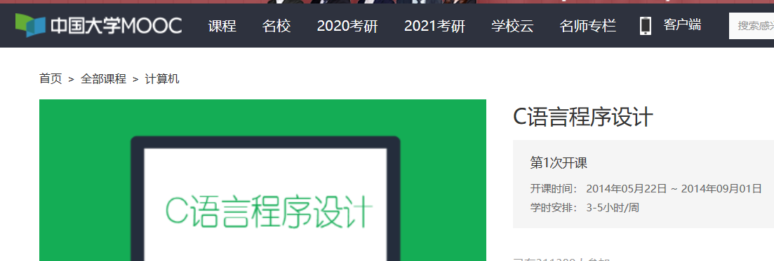](https://github.com/ECNU-DEIT-ACADEMIC-2019/PAT/blob/master/3.4.2.PNG?raw=true)[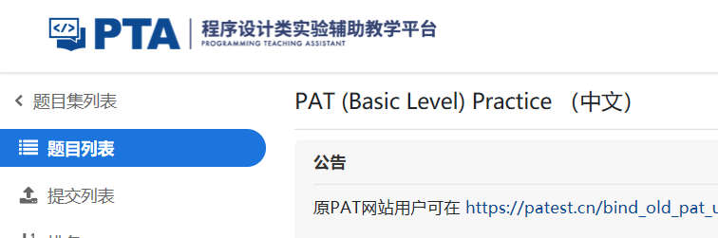](https://github.com/ECNU-DEIT-ACADEMIC-2019/PAT/blob/master/3.4.3.PNG?raw=true)

## 4. User experience

User experience analysis includes investigating user’s subjective rating or opinion reacting to using PAT and analysing the function, style, color, layout, interaction of system based on design principles.

### 4.1. Result of survey

We designed a easy questionnaire to investigate students from Zhejiang University about their experience of using PAT. Result indicated that majority of users are sophomores(86.67％) and boys(80％). They used the platform mainly to do exercises and learning. The average score of style, layout, interaction and function was respectively 4.70, 4.73, 4.33, 4.50.

[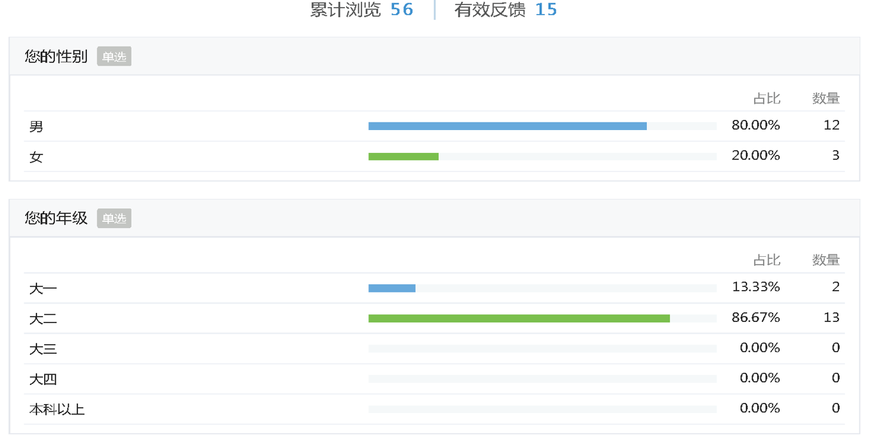](https://github.com/ECNU-DEIT-ACADEMIC-2019/PAT/blob/master/4.1.1.png?raw=true)[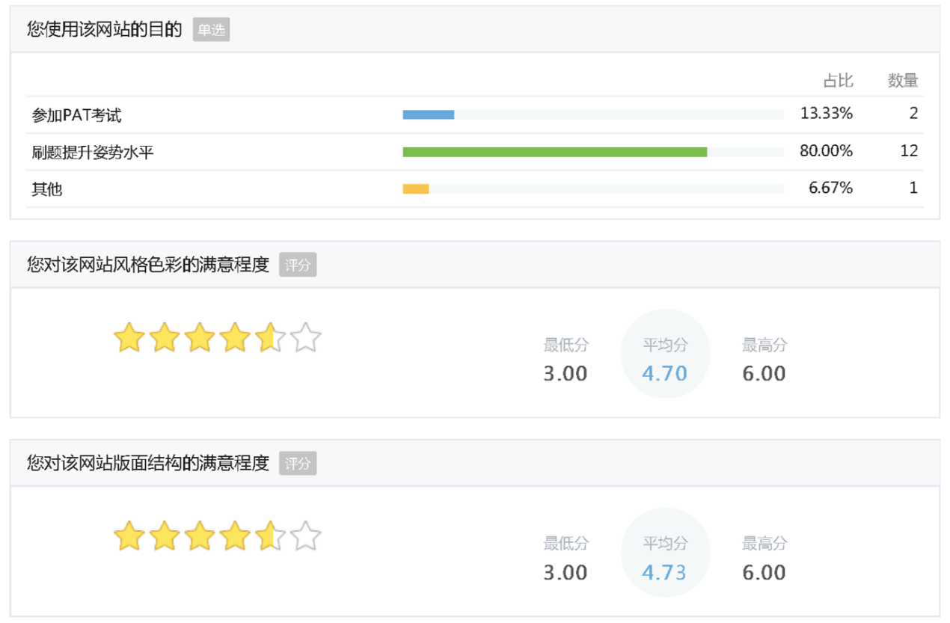](https://github.com/ECNU-DEIT-ACADEMIC-2019/PAT/blob/master/4.1.2.png?raw=true)[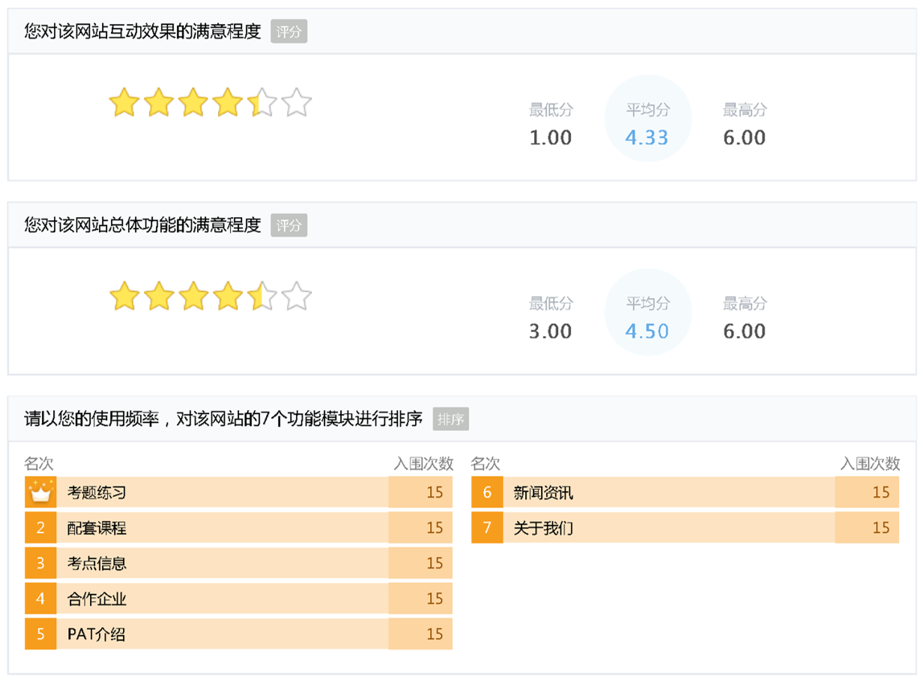](https://github.com/ECNU-DEIT-ACADEMIC-2019/PAT/blob/master/4.1.3.png?raw=true)[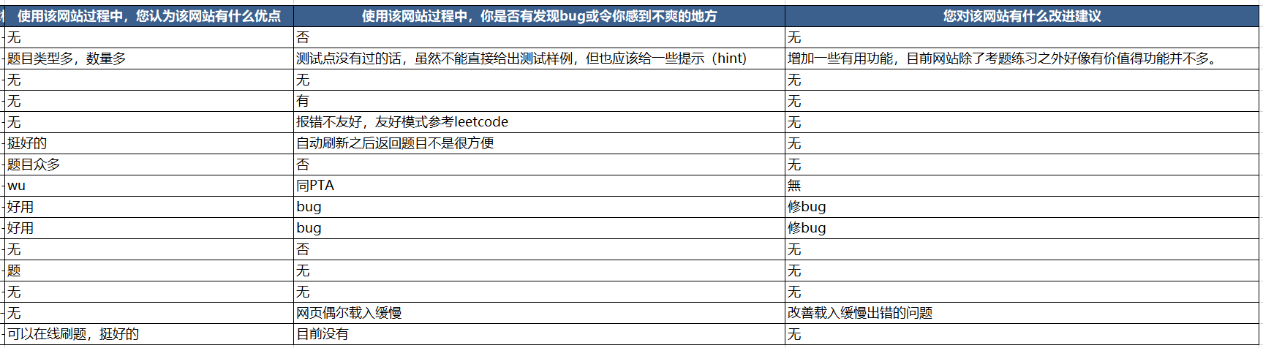](https://github.com/ECNU-DEIT-ACADEMIC-2019/PAT/blob/master/4.1.4.png?raw=true)

### 4.2. Style

The platform generally adopted a simple style and neutral color.Compared with the complex design style, simplified design conforms to the theory of cognitive psychology, which strengthens the visual center and provides appropriate blank space.In addition, simplified design helps to screen out redundant information resources and enables users to obtain useful information efficiently.

### 4.3. Layout

From the perspective of psychology, the memory capacity and time of users are limited. Dealing with more than seven objects at the same time causes cognitive load. It is necessary to control the amount of information transmitted, organize the layout in harmony to achieve a rich, balanced and consistent visual effect.The layout of PAT applied the principles in order to save browsing time and improve learning efficiency.

### 4.4. Interactive response

On the whole, PAT applies a fairly good interaction with fast and effective response, considering operability and complexity.For example, when the mouse moves to an operable position, the platform will immediately give feedback and perform user operations.

### 4.5. Function

The most popular function of PAT lies in its examination section which provides programming test exercises. Compared with similar learning platform such as LeetCode ([www.leetcode.com](http://www.leetcode.com/)), PAT has a larger question database and topics.At the same time, after submitting the source code, the system will give feedback timely through the background evaluation, which contributes to finding problems and solving problems for users. In addition, the questions provided by the platform are very interesting. It is not difficult to find interesting titles such as "Play cute", "Single Dog", "Microblog Forwarding Lottery" and so on, which greatly motivates the user's learning interest.

## 5. Limitation and suggestions

#### 5.1. Prompts and instructions should be given if the code runs into an error.

#### 5.2. As the accompanying courses and exercises are directly linked to external websites, to return to the interface of PAT platform, one can only click back or re-enter, which needs to be improved.

#### 5.3. An online assistant can be set to answer questions online at any time to answer any questions encountered by users in the process of using the platform, so as to enhance the intelligence and sense of belonging of the platform.